Blue Food Demand Across Geographic and Temporal Scales
Rosamond L. Naylor¹, Avinash Kishore², U. Rashid Sumaila³ (lead authors)
Ibrahim Issifu³, Blaire P. Hunter¹, Ben Belton^{4,5}, Simon R. Bush⁶, Ling Cao⁷, Stefan Gelcich⁸, Jessica A. Gephart⁹, Christopher D. Golden¹⁰, Malin Jonell¹¹, J. Zachary Koehn¹, David C. Little¹², Shakuntala H. Thilsted⁴, Michelle Tigchelaar¹, Beatrice Crona¹¹

Abstract

Numerous studies have focused on the need to expand production of 'blue foods', defined as aquatic foods captured or cultivated in marine and freshwater systems, to meet rising population- and income-driven demand. This paper analyzes the roles of economic, demographic, and geographic factors and preferences in shaping patterns of blue food consumption. Results show a weak cross-sectional relationship between per capita income and consumption globally when using an aggregate metric of fish. Disaggregation by fish species group reveals distinct geographic patterns; for example, high consumption of freshwater fish in China and pelagic fish in Ghana and Peru where these fish are widely available, affordable, and historically established in cuisines. The nutrition and environmental impacts of fish consumption, projected to grow by 82% in edible weight and almost double in live weight from 2015 to 2050, will depend on substitution among fish groups and other animal source foods in national diets.

1. Introduction
Understanding the demand for aquatic foods is critical for assessing their current and future role in global food systems. A common view is that the production of aquatic foods, referred to here as 'blue foods' captured from or cultivated in marine and freshwater systems, will need to expand in coming decades to meet population- and income-driven demand. The regional and species-specific aspects of demand are often obscured, however, raising questions about the alignment of demand and supply across a diverse array of aquatic food systems. This paper examines blue food demand for multiple species groups across regions over time. Unlike other papers that present comprehensive models of fish demand¹⁻⁵, this study provides a synthetic analysis based on secondary data, published model results, and case studies at national to sub-national scales to characterize the diverse and changing nature of blue food consumption. It also compares consumption patterns for fish and terrestrial meat that are substitutes in demand. Together, this assessment of blue food demand across geographies and time horizons provides insight into the nutritional and environmental outcomes of changing diets, as discussed in the final section.
The conceptual framework for this study aligns with consumer theory^{6,7} characterizing blue food demand as a function of population, income, relative prices, and preferences; other household characteristics such as employment and urban versus rural residence are embedded in preferences. Consumption is determined by a two-step budgeting process wherein consumers first allocate expenditures among separate groups of goods (for example, food versus non-food) and then allocate spending within each group (for example, different types of fish or fish versus terrestrial meat). Food typically comprises a large budget share for low-income consumers, making their food purchases more responsive to changes in prices and income than wealthy consumers. Accordingly, the income elasticity of demand for food in the aggregate, a metric of the responsiveness of demand to changes in income (see Methods), is higher for low-income populations than for high-income populations and declines with income growth (Engel's Law)^{8,9}. In addition, consumers diversify food expenditures according to price and quality as their incomes increase, spending less of their budget on staple foods and more on luxury items. Income elasticities of demand are thus greater for high market-valued foods, including aquatic and terrestrial animal products, than for low market-valued staple foods^{9,10}. Since some wild fish are used for fishmeal and fish oil in animal feeds, demand for fish as a feed ingredient is expected to rise with per capita income growth⁵. These patterns provide a foundation for assessing both time series and cross-sectional trends in blue food demand within the global food system.
The availability and affordability of blue foods also influence consumption patterns. Small island nations with an abundance of wild fish in their ocean territories record especially high per capita fish consumption (SI.1). In other regions, particularly throughout Asia, the expansion of aquaculture has driven down real prices for farmed fish produced in large volumes, making them increasingly accessible to low-income consumers¹¹. Meanwhile, wild capture fish have become more expensive, both in real terms and relative to farmed fish, often restricting their accessibility to primarily wealthier consumers¹²⁻¹⁴. Given the geographic patchiness of wild fish and aquaculture production, trade is critical for meeting fish demand in many parts of the world. Fish imports are especially important in countries where per capita fish demand is rising, aquaculture is limited, and wild fish capture for domestic consumption is stagnant or declining¹⁵. Seafood is among the most highly traded commodities in the global food system^{16,17} and has become increasingly globalized, with trade approximately doubling in terms of quantity and value from 1998 to 2018¹⁸.
The interaction of income, prices, and preferences drives dietary diversification and substitution in demand for different animal source foods, including fish, across countries¹⁰. Preferences are shaped by geographic location, dietary history, culture, time constraints, out-of-home consumption, nutritional knowledge, health and sustainability concerns, and other social and behavioral dynamics^{7,19-22}. Geographies with long coastlines or significant inland water systems have strong traditions of blue food consumption^{19,23}. As the food share in total expenditures declines with income growth, the role of preferences in consumer choice rises^{7,20}. Fish products are now consumed in non-traditional ways, such as sushi and sashimi^{24,25}, and markets for sustainably rated or certified fish are expanding^{26,27}, reflecting income growth and changing tastes. Diverse preferences have fostered use and trade in by-products, not just edible fish or fish fillets²⁸. For example, salmon heads from Norwegian and Scottish aquaculture find viable markets as human food throughout Southeast Asia, and shrimp shells and pangasius oil from Vietnam are used in medical and agricultural products (chitosan) and in livestock feed formulation, both domestically and after the edible fish products are exported to China²⁹. Fish processing wastes are increasingly used to produce aquaculture feeds²⁷. Although our analysis focuses on patterns of fish consumption for human foods, the overall demand for aquatic animals, algae, and plants also encompasses a wide array of industrial uses and animal feed products²⁸.
This study covers three tiers of analysis: global, as represented by 72 countries drawn from all continents and constituting over 80% of all blue food consumption; regional, based on the two largest fish consuming countries in each of five continents -- Asia, Africa, South America, North America, and Europe -- accounting for 55% of global consumption (each region comprising 5% or more of the global total); and national, through four country-level investigations of blue food demand (China, India, Nigeria, and Chile). Consumption is captured by apparent consumption data taken from FAO food balance sheets³⁰ and does not directly measure dietary intake. Edible conversion weights and income elasticities from the literature are used to estimate current and future blue food consumption and to compare fish to terrestrial meat consumption (see Methods). The terms 'blue foods', 'seafood', and 'fish' are used interchangeably throughout this study to denote marine and freshwater finfish (including diadromous fish), crustacean, and mollusc species, as reported by FAO (SI.2). Although aquatic plants, seaweed, and aquatic animals other than fish and shellfish are important for food and nutritional security in certain locations, they are not included in our analysis due to data limitations.

2. Results
2.1 Global fish consumption
Our global analysis focuses on population and income per capita as major determinants of blue food consumption. During the 20-year period from 1998 to 2018, global average fish consumption per person rose from 15.6 to 20.4 kg/year on a live-weight basis, and from 11.5 to 15.1 kg/year in edible weight³⁰. Multiplying these figures by the growing population, the aggregate volume of fish demand (live-weight) increased from 93.6 to 152 million tonnes (Mt)³⁰.
Income growth and associated changes in dietary habits have been shown to be a more influential driver of fish demand in recent decades than population growth at the global scale^{3,5}. Cai and Leung³ disaggregated the effects of population growth and consumption per capita for the period 2008-2013 and found that they accounted for 40% and 60%, respectively, of the increase in global fish demand. Their results showed considerable regional variation; in Sub-Saharan Africa the contribution of population growth to total demand was 90%, while in East Asia (mainly China) where economic growth was much stronger and population growth relatively weak, population accounted for only 13% of the overall increase in fish demand. Asia was the source of virtually all of the increase in global fish consumption over this period, suggesting that Asian countries are undergoing a significant dietary transition, one that is just beginning in Sub-Saharan Africa.
To assess the role of income in blue food consumption globally, we use an aggregate metric for fish following the demand model of Muhammad et al², and then compare correlations between per capita income and consumption of fish versus terrestrial meat with cross-sectional data (see Methods). Figure 1 reveals a weak correlation (r=0.26) between per capita income and apparent fish consumption across the 72 countries in our global dataset. The correlation between per capita income and consumption of terrestrial meat, on the other hand, is higher (r=0.67), reflecting the nutrition transition whereby meat consumption rises steadily with income growth and tapers off at higher levels of income¹⁰. These results are consistent with estimates by Muhammad et al.³¹ showing a uniformly higher income elasticity of demand for meat than for fish and suggesting that consumers have a stronger preference for meat over fish at mid- to high levels of income.
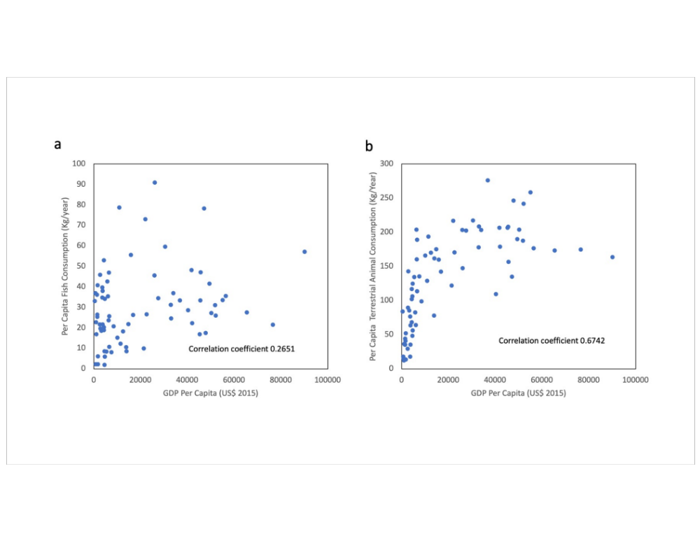
Fig. 1: Relationship between animal fish and meat consumption and GDP per capita for 72 countries (2015) in live weight. (a) Per capita fish consumption as a function of GDP per capita. (b) Per capita terrestrial animal consumption as a function of GDP per capita. The relationship between per capita consumption and GDP per capita is significantly weaker for fish than for terrestrial meat, with correlation coefficients of 0.2651 and 0.6742, respectively. Countries with very high per capita consumption of fish (> 50 kg/cap/year, live weight) include French Polynesia, Maldives, Fiji, Antigua & Barbuda, Iceland, Malaysia, Barbados, Lithuania, Spain, South Korea, Portugal, and Norway. Data sources: The World Bank (https://data.worldbank.org/) and FAOSTAT¹⁸.
A key explanation for the weak relationship between income and fish consumption per capita is that 'fish' comprise thousands of different species captured or cultivated in a wide array of freshwater and marine systems. The diversity of seafood consumed globally is substantially higher than that of terrestrial meat, which is dominated by a relatively small number of cattle, poultry, and swine breeds. Previous models of fish demand have shown that consumption of blue foods cannot be characterized by a single 'fish' variable, as preferences and income elasticities of demand differ widely between low versus high market-valued fish^{1,3,5}. Fish consumption also tends to be measured less accurately than terrestrial meat in FAO data due to the wide variety of edible products³². Preserved blue foods (dried, salted, fermented, smoked) account for a substantial share of fish consumption, particularly in Southeast Asia and Africa, adding nutrients and distinct flavors to local cuisines^{15,33-35}. In the Mekong River Basin, small quantities of dried or otherwise processed fish account for 15% of fresh whole animal equivalent weights³⁶, and in Myanmar they constitute roughly one-third of all blue food consumption¹².
Terrestrial meat and fish are often grouped together in analyses of diet diversification^{9,10,32}, yet disaggregation by beef, pork, poultry, and seafood is critical for understanding substitution in demand. During the past 60 years, poultry consumption has increased while beef consumption has declined; between 1961 and 2017, global annual growth in edible per capita consumption was 3.4% for poultry, 1.6% for seafood, 1.4% for pork, and -0.8% for beef (Fig. 2). Although substitution of fish for beef has been advocated on health and environmental grounds^{37,38}, poultry appears to have already served as a major substitute for beef in global diets. The convergence of global per capita fish and poultry consumption at 15-16 kg/cap/year in edible weight (Fig. 2a) reflects similarities in industrial organization, processing techniques, and nutritional and cuisine attributes³⁹. Prices for the two commodities have been shown to be roughly equivalent (as measured against the price of staple calories) in a few large countries undergoing nutritional transitions, such as China and India, but show greater divergence in other countries that have varied availability and tastes for fish versus poultry⁴⁰. Preferences have long been recognized as a major factor in consumer choice of animal source foods^{7,41}, highlighting the need for analyses at regional to sub-national scales where geography, culture, and tastes can be differentiated.

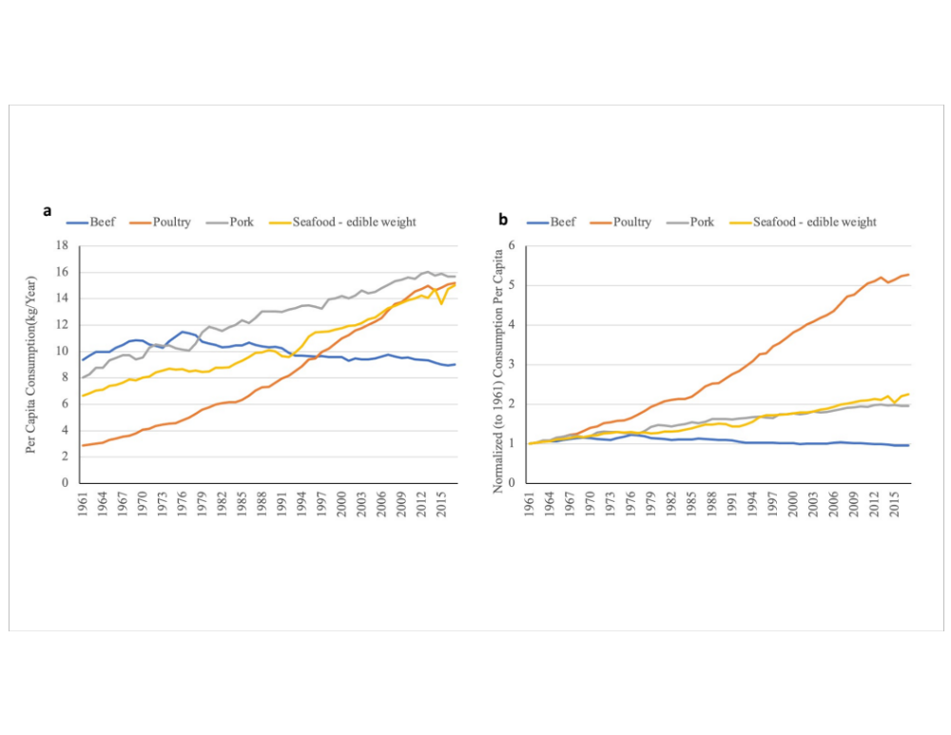
Fig. 2: Global animal meat and fish consumption by type (1961-2017) in edible weight. (a) Per capita animal consumption by type. Annual per capita consumption of poultry increased five-fold from ~3 kg to 15 kg, while that of seafood more than doubled from ~7 kg to nearly 16 kg. Global annual per capita consumption of beef has declined since mid-1970s. In 2017, in absolute terms, seafood and poultry meat consumption appeared to be converging with pork tapering off. (b) Normalized global per capita animal protein consumption by type. Time series data for each protein type from 1961 to 2017 were normalized (pegged) to 1961. The annual growth rates of poultry meat, seafood, pork and beef are 3.4%, 1.6%, 1.4%, and -0.08% respectively. Data Source: FAOSTAT¹⁸

2.2 Regional fish consumption and trade
To capture the regional heterogeneity of blue food demand, we disaggregate fish consumption into seven major species groups: freshwater fish (including diadromous fish such as salmon), demersal (e.g., cod, halibut), pelagic (e.g., tuna, forage fish), other marine fish, crustaceans, cephalopods (e.g., squid, octopus), and bivalves (SI.2). There are distinct patterns of seafood consumption across regions (Figure 3); for example, relatively large shares of freshwater fish consumption in Asia, pelagic and freshwater species consumption in Africa and South America, and demersal species in Europe, North America, and Oceania. Per capita fish consumption in Asia, Europe, and Oceania exceeds the global average, whereas Africa and South America are well below the global average.
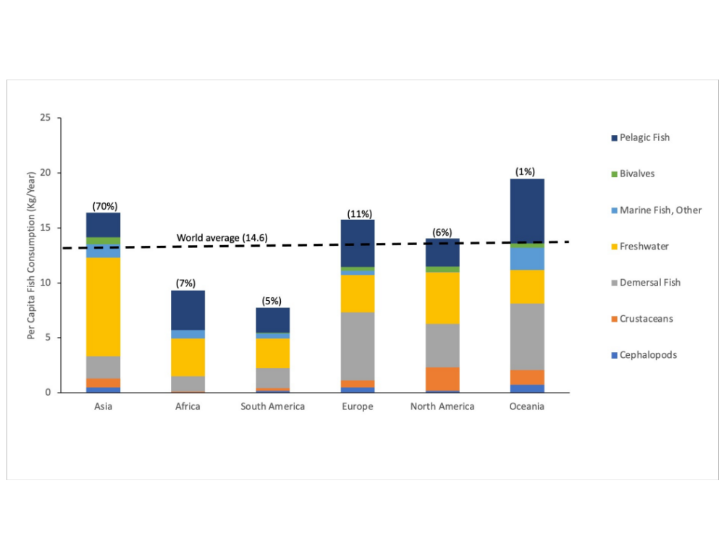
Fig. 3: Per capita fish consumption by region by species group (kg/cap/year, edible weight) in 2015. Numbers in parentheses above the bars represent the share of global consumption. Asia, Europe and Oceania demonstrate a high level of edible fish consumption per capita in relation to the global average (14.6 kg/cap/year). Fish consumption in North America is close to the global average, whereas Africa and South America are significantly below the global per capita average. Fish consumption in Asia is dominated by freshwater species, whereas fish consumption in Europe, North America and Oceania is more diverse. In Africa and South America, fish consumption is comprised of pelagic and freshwater species, and to a lesser extent demersal and marine species. Data Source: FAOSTAT¹⁸

Viewing consumption patterns over time for individual countries within regions sheds more light on the roles of preferences, availability, and economic determinants of demand. Figure 4 illustrates relative levels of fish consumption per capita as well as changes in the types of fish eaten across the largest consuming countries from 1975 to 2015. This set of countries is confined to regions accounting for 5% or more of global consumption and for each region, includes one country representing high per capita consumption-- up to 30 kg/year, twice the global average -- and one representing relatively low per capita consumption but large populations. A cursory look at the types of fish consumed in each region demonstrates that China is the dominant consumer of freshwater fish, while Ghana and Peru are large consumers of pelagic fish (especially small forage fish). Fish consumption in Europe and North America is highly varied, with relatively large consumption of high market-valued demersal fish, crustaceans, and pelagics including tuna. Per capita consumption of bivalves is greatest in Europe and in China.
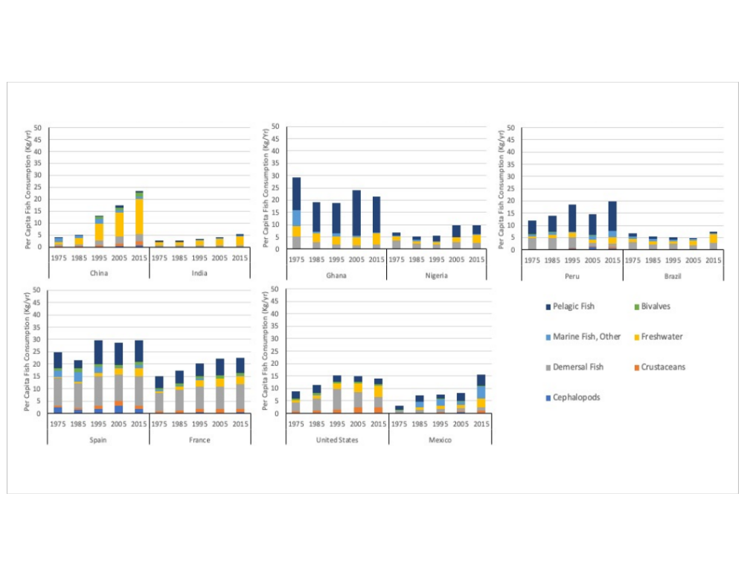

Fig. 4: Per capita fish consumption by region for selected species groups (kg/cap/year, edible weight) from 1975-2015. Asia (China and India): Widespread consumption of freshwater fish, but China is also a large global consumer of bivalves. Africa (Ghana and Nigeria): High consumption of small pelagic fish and freshwater species. South America (Peru and Brazil): All categories of fish species consumed, with high consumption of pelagic fish in Peru. Europe (Spain and France): Wide mix of fish groups consumed, with a strong preference for demersal fish, followed by bivalves and pelagic fish. North America (United States and Mexico): All categories of fish species consumed with high consumption of crustaceans in U.S. relative to most other countries in the regional analysis. Each region in the figure accounts for 5% or more of global consumption as indicated in Fig 3 and thus exclude Oceania, which accounts for only 1% of global consumption Data Source: FAOSTAT¹⁸
.

Delineating fish by species group is also critical for understanding trends in fish trade, as demand is met by both domestic production and imports. The volume of fish trade for the seven species groups in our 10-country regional dataset reveals several interesting patterns (Fig. 5). China is the leading global fish exporter but also ranks as one of the top importers of fish across all species groups, notably pelagic and demersal species. The U.S., France, and Spain are also large importers of most species groups, with the exception of pelagic and marine fish. The U.S., a large producer of farmed catfish during the past half century, has become the world's leading importer of freshwater fish as well as crustaceans. Although India has the lowest per capita consumption of fish in our regional dataset, it is the second largest exporter of fish overall and the largest net exporter of crustaceans. As fish supplies increase in India, however, consumption per capita is also rising^{11,42}. Demand for higher market-valued marine and freshwater species, both farmed and wild, is rising in several Asian countries as production and incomes rise, gradually redirecting products once produced mainly for export to domestic markets^{11,27,43,44}.
The dominance of certain countries in international fish trade masks the importance of trade for Africa, where imports of frozen fillets and small pelagic fish have been rising as production from domestic fish capture has either stagnated or been exported¹⁵. Fish demand has grown faster than supply in Africa, resulting in an increase in the import share from 16% in 1970 to 39% in 2017 -- a major jump given that the import share for food in aggregate was 13% in 2017¹⁵. In Nigeria, fish have traditionally been among the cheapest animal source foods, but limited domestic supplies and rising imports of frozen fillets have caused real fish prices to rise significantly during the past decade¹⁵.

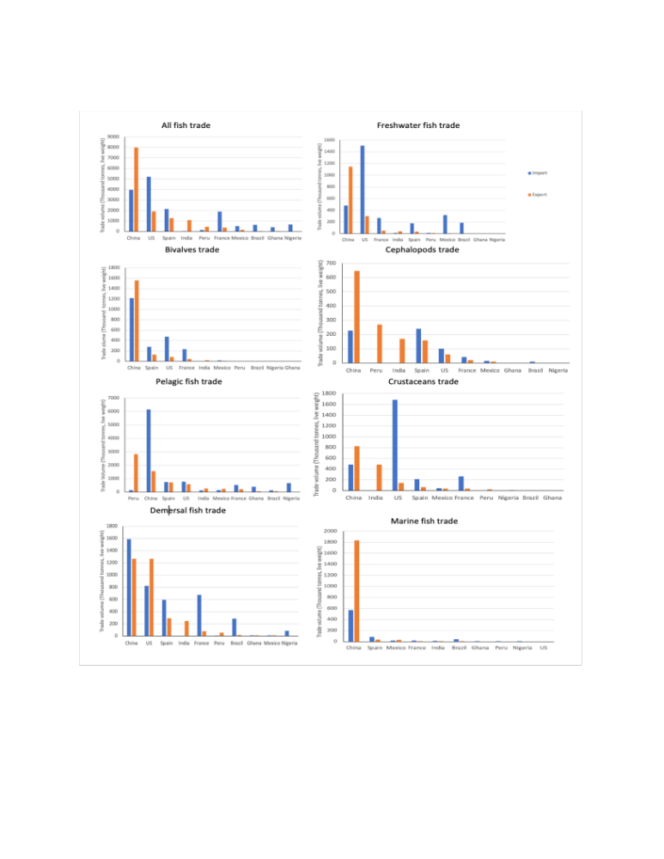
Fig. 5: International trade in 2016 of all fish and seven species groups (in 1000 tonnes, live weight) for 10 countries in our regional comparison set. Note that the data displayed cover only fish supply for human consumption. For all fish trade destined for human consumption, China is by far the leading exporting country, followed by India and Peru, while the USA, France, and Spain are principal importers of all fish species. Data Source FAOSTAT
.

Real prices of blue foods, particularly relative to terrestrial animal products that substitute in demand, are important determinants of consumption, with low-income households being more responsive to price than wealthy households^{1,3,5,8}. Global price indices for fish are limited and do not capture the diverse range of species consumed across geographies and countries at different stages of economic development (SI.3). Prices have been recorded, however, for a wide variety of standardized fish and meat products through the World Bank International Comparison Program (ICP) in 2011 and 2017⁴⁵. During this period, the price of fish rose in all 10 countries in our regional analysis, while meat prices were more stable overall, particularly relative to fish (SI.4). Using ICP data to calculate the relative caloric price of seafood to staple grains, Headey and Alderman⁴⁰ found that fish are comparatively expensive in low-income countries and cheap in high-income countries. In Asian countries where availability is high, fish are a relatively affordable source of animal source foods⁴⁰.

2.3 Country-specific examples
Case studies China, India, Nigeria, and Chile provide further insight into geographic patterns of blue food demand at national and sub-national scales. These countries were selected for the following reasons. China is the world's most populous country and the largest producer and consumer of blue foods. China and India together account for over two-thirds of Asia's population and one-third of the global population⁴⁶, and both have experienced rapid economic development. Fish consumption per capita in India is significantly lower than China and highly varied at the sub-national scale due to cultural and geographic factors. Nigeria has the largest population in Africa, projected to exceed 400 million by 2050, surpassing the U.S. as the world's third most populous nation⁴⁶. Although Chile is much smaller than the above-mentioned countries, it serves as an interesting case given its decline in per capita fish consumption in recent decades despite its geography (long coastline), cultural history of seafood consumption, and vibrant capture fisheries and aquaculture sectors. Across these four countries, the relationship between income growth and fish consumption per capita shows apparent differences (Fig. 6).
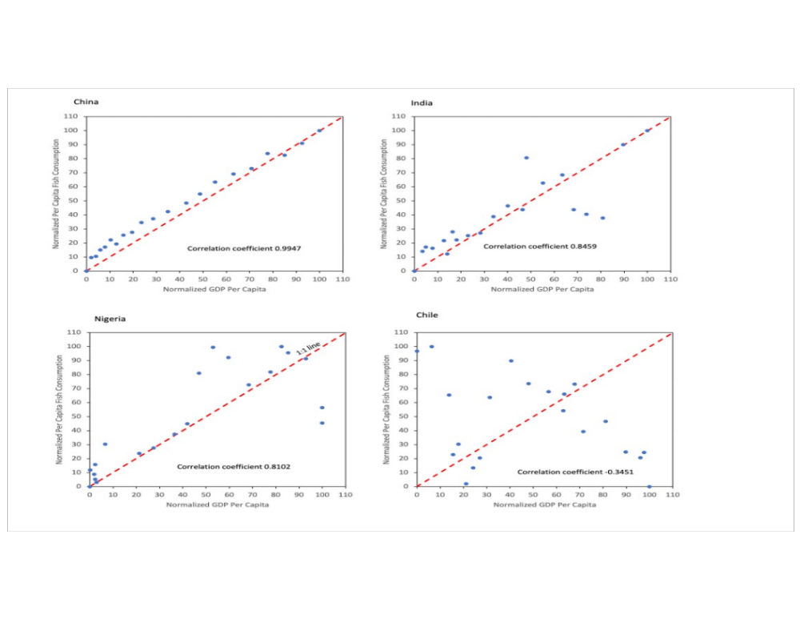
Fig. 6: Per capita fish consumption relative to GDP per capita for four selected countries (1995-2015). Both GDP per capita and per capita fish consumption (live weight) were normalized between 0 and 100 for comparability. Each year is represented by a blue dot. China shows a strong positive correlation between consumption per capita and GDP per capita (r=0.99); India and Nigeria show a moderately high positive correlation between fish consumption per capita and GDP per capita (r=0.85 and 0.81, respectively), with greater variation at mid to high income levels; Chile shows a negative correlation between consumption per capita and GDP per capita (r=-0.35), with fish consumption falling as income rises. Data Source: FAO¹³.

2.3.1 China
China is the largest producer, consumer, processor, and exporter of fish globally, and its imports of fish have been rising in recent decades^{43,44,47}. Per capita consumption of fish (edible weight) increased five-fold between 1975 and 2015 (Fig. 4) and is projected to rise by almost 50% from 2015 to 2050 (Fig. 8). More than 95% of China's production and domestic consumption of fish are concentrated in the eastern, southern and central regions, while consumption in the western region remains extremely low⁴⁸. A gap also exists between urban and rural fish consumption. Chinese National Statistics reported fish consumption of 16.7 kg/cap in urban areas and 9.6 kg/cap in rural areas on average in 2019, with consumption exceeding 25 kg/cap/year in eastern cities and as low as 1 kg/cap/year in western provinces⁴⁸. It is worth noting that urban fish consumption may be underestimated by 25-30% because government reports omit out-of-home consumption^{49,50}.
Freshwater aquaculture systems have supported local demand for fish in China for centuries and have expanded under government incentive programs since the mid-1980s when the country's capture fisheries became over-exploited. With its long coastline, local marine fish such as yellow croaker have long been part of Chinese diets, but consumption of freshwater fish, molluscs, and even non-traditional salmon products has risen with domestic aquaculture expansion^{27,51}. Production from aquaculture (both freshwater and mariculture) exceeded that of wild fisheries in 1988, and now contributes over three-quarters of China's total fish supplies⁴⁷. Consumption of marine species has tripled over the same period, and the gap between inland and coastal consumption of marine fish has narrowed with supply chain advances in logistics and cold chain technology⁵². Consumption of all animal source foods have increased in China since 1975 (Fig. 7). Although pork remains the dominant animal source food in the average Chinese diet, the demand for fish has been rising with income growth (Fig. 6) and is often preferred as a healthy food to terrestrial meat.⁵³ Demand for eco-labeled seafood in China is also increasing⁵⁴, albeit from a low level.

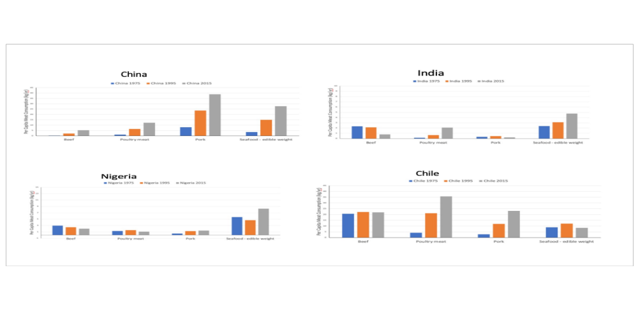
Figure 7: Per capita animal source food consumption: beef, poultry, pork, and seafood (1975, 1995, and 2015). Seafood includes all freshwater and marine species of finfish, crustaceans, cephalopods, and molluscs in edible weight with conversion from live-to-edible based on conversion factors reported in the Methods section. Note the differences in scales along the y-axes, indicating that India and Nigeria consume significantly less seafood and meat on a per capita basis than China and Chile. Seafood consumption per capita has risen in all locations except for Chile, where terrestrial meat consumption (particularly poultry and pork) has increased significantly. China has higher consumption per capita of pork than seafood. Data source: FAOSTAT¹⁸.

2.3.2 India
India is the second-largest producer and consumer of fish globally and a leading exporter, although consumption per capita is well below the world average (Fig, 5, SI.5). National Sample Survey Reports from 1987-88 to 2011-12 show that average consumption increased from 1.92 to 2.64 kg/cap/year and the share of households consuming fish regularly rose from 27% to 32%; however, one-third of all households in India reported eating no fish at all in 2011-12^{55,56}. Annual per capita fish consumption estimated from national survey data was below that published by FAO (Fig. 4), underscoring major estimation and reporting inconsistencies at the national scale.
National Sample Surveys reveal substantial variation in fish consumption among states⁵⁶. Ninety percent of all households in Assam, Kerala, and West Bengal eat fish regularly, compared to less than 2% of households in Himachal Pradesh, Haryana, Punjab and Rajasthan. In states where fish is not a common food, urban and wealthier households report lower consumption than their rural and poorer counterparts. Fish consumption is also higher in Muslim versus Hindu households, and in Schedule Tribe versus upper caste households. Households that do not consume fish typically adhere to vegetarian diets and are significantly less likely to report consumption of meat (beef, chicken, mutton, or pork) or eggs. Fish consumption is more common in the predominantly rice-eating southern and eastern states -- mainly due to agroecological conditions, availability, and regional cuisines -- than in the north and western parts of the country where wheat is the staple food¹⁹.
Given wide inter-state variation, national-scale projections may misestimate future fish consumption. Existing projections use single values for income and price elasticities of fish demand for the entire country^{1,5,42} despite significant differences in consumer behavior among states (e.g., authors' calculations⁵⁶ indicate the income elasticity of demand for fish is higher in the east and south than in the north). For India as a whole, poultry consumption has increased in recent decades along with fish, whereas beef and pork consumption has fallen (Fig. 7). Milk consumption per capita (not shown in Fig. 7) was significantly lower for households where fish was consumed across all income classes⁵⁶. In addition, butter, ghee, and eggs are substitutes for fish in Indian diets⁵⁷.

2.3.3 Nigeria
Apparent fish consumption in Nigeria is estimated at 11 kg/cap/year, slightly higher than the regional average for Africa (9.9 kg/cap/year) and substantially lower than the global average of 20.3 kg/cap/year³⁰. Fish plays a major role in average Nigerian diet, with roughly half of the population eating fish two to three times per week⁵⁸. Like India and China, however, there are sub-national differences, with households in southern Nigeria consuming about twice as much fish as those in the north¹⁵. Per capita fish consumption is higher in urban than rural areas, particularly for fresh (versus dried) fish, and middle- and high-income households eat fish more frequently than do lower-income households⁵⁹. Households in the south also consume more frozen imported fish than in the north. Higher levels of fish consumption in the south reflect its proximity to the coast, and hence historical preferences and access to imports, as well as its relative success in aquaculture development¹⁵.
Household consumption of fish exceeds terrestrial meat in Nigeria, although pork consumption has risen in recent decades (Fig. 7). Local studies suggest that affordable, small pelagic and preserved fish (dried and smoked) are most widely consumed, but imported frozen fish now comprise the largest budget share of seafood consumed across the country on average, despite lower nutritional benefits in relation to small indigenous fish^{15,34}. Given steady growth in fish demand, Nigeria has invested heavily in aquaculture production (mainly freshwater catfish), accounting for 52% of sub-Saharan Africa's farmed fish output⁶⁰. Replacing locally diverse fish species with imported demersal fish and farmed freshwater fish has mixed nutritional consequences for the population as a whole, especially since affordability acts as a constraint on fish consumption for poor households^{33,40,61}.

2.3.4 Chile
With a long coastline and extensive freshwater bodies in the south, fish consumption has traditionally played an essential role in the diets of many Chileans. An estimated 46% of all households in Chile consume fish at least once a week, and 55% of high-income and 38% of low-income households consume fish weekly⁶². Despite Chile's culinary history, per capita consumption of fish has fallen during the past two decades while consumption of poultry and pork has increased (Fig. 7). A shift in dietary preferences, and a re-orientation of domestic capture fisheries toward global markets, help to explain this trend.
Chile is the second largest producer and leading exporter of mussels globally. Expansion in the mussel industry has been driven by strong international demand, mainly by European countries (Spain, France, and Italy), which together with Russia and the U.S., accounted for 69% of Chilean mussel export quantities in 2019⁶³. Domestic fish consumption, has decreased in response to rising prices over the past 15 years, a trend which artisanal fishing communities are trying to revert ⁶⁴. Local consumption of high market-valued species of molluscs that are sold in luxury export markets, such as the gastropod named loco (Concholepas concholepas), has fallen dramatically⁶⁵. The salmon aquaculture industry in Chile is also export-orientated, with output destined mainly for markets in high-income nations such as the U.S., Japan and EU⁶⁶. Chilean consumers have not yet demonstrated a strong domestic preference for farmed salmon despite large-scale domestic production⁶⁷.
National health and environmental consequences of shifting diets from fish to terrestrial meats, in addition to the environmental implications of expanding the production of intensive salmon aquaculture to meet rising international demand, illustrate the influence of global markets on nutrition and sustainability outcomes in countries like Chile that are significantly engaged in blue food trade.

2.4. Fish Consumption to 2050
To assess future fish demand, we begin by using regional values of per capita fish consumption disaggregated by species in 2015 (Fig. 4) and examine how these amounts will change by 2050 with population and income growth (see Methods). Prices are held constant in our demand projections as we do not create a closed model that solves for price endogenously with supply estimations. Our projections do not represent a linear extension of 2015 consumption patterns, as consumption of different types of fish will change with income growth (depending on the relevant income elasticity of demand), typically favoring higher market-valued products as countries become richer.
Based on this structural demand forecast, per capita fish consumption, measured in edible weight, is projected to increase in all regions, more than doubling from the current global average consumption of 15 kg/cap/year³⁰ in half of the 10 countries by 2050 (Fig. 8). Asia will continue to lead in demand for freshwater fish, with total edible fish consumption in India more than tripling from 6.2 Mt to 19.8 Mt due to its large and growing population (~1.6 billion by 2050)⁴⁶. Projections based on FAO data may overstate India's future fish consumption as discussed above, but even at half the projected national per capita consumption level, India's population-driven demand will be large. Meanwhile, China's population will fall below India's by 2050 (projected at ~1.3 billion)⁴⁶, but its per capita consumption is projected to rise from 29 kg/cap in 2015 to 37 kg/cap in 2050, leading to an aggregate increase in edible demand from 39.9 Mt in 2015 to 53.1 Mt. Projections show China demanding a diverse set of species in 2050 including crustaceans, demersal fish, and cephalopods. Africa will continue to dominate consumption of small pelagic fish, with Ghana showing the largest demand in the region on a per capita (edible) basis at 32 kg/cap in 2050. Nigeria has lower consumption per capita but a substantially larger population than Ghana; by 2050, Nigeria's aggregate edible fish consumption is projected at 4.6 Mt, significantly higher than Ghana's at 1.7 Mt (SI.3). Europe and North America will continue to consume a wide variety species.

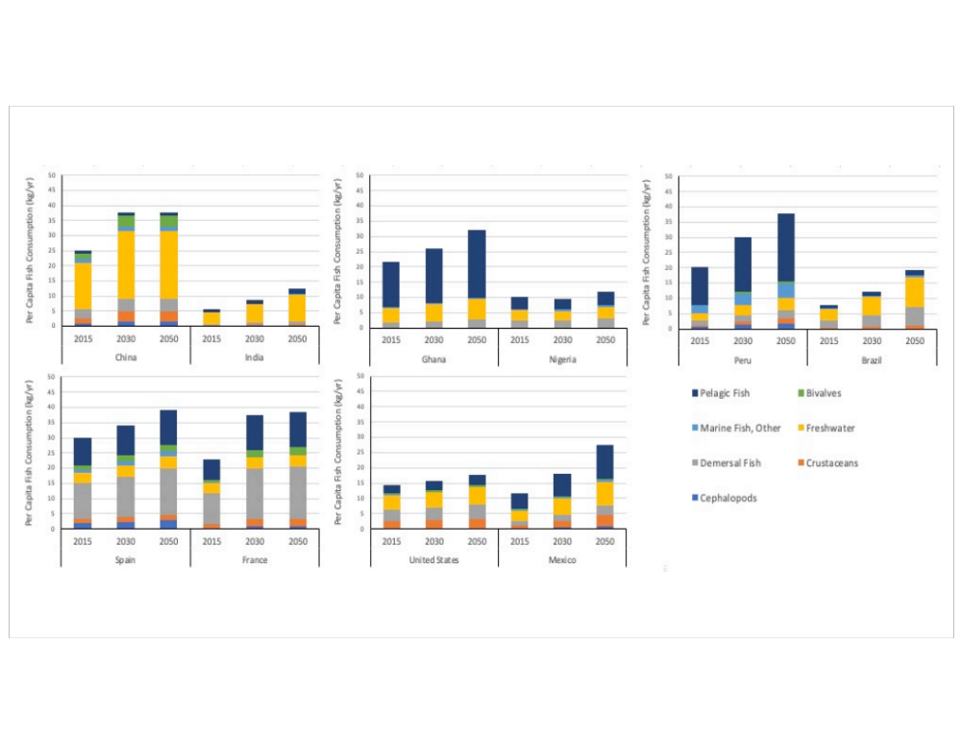
Fig. 8: Per capita fish consumption for species groups in the 10 selected countries (kg/year, edible weight), 2015-2050, based on projections of growth in population, income per capita, and income elasticities of demand by species group (see Methods). The order of the regions and countries is designed to match that of Figure 4. Asia: Freshwater fish and overall consumption continue to grow across all countries, but per capita consumption remains relatively low in India. Africa: Pelagic fish continue to play an important role in fish-consuming countries. Nigeria’s slow recovery from an economic recession in 2016 and COVID dampen predicted consumption. South America: Europe: Growth in fish consumption is higher in France and Spain stays relatively constant at the current high consumption rate. North America: Fish consumption is predicted to stay relatively constant and low in the United States, with more significant growth in Mexico. Data on fish consumption per capita in 2015 are taken from FAO Food Balance Sheets³⁰. See SI.5 for more information.

Overall, our projections show that aggregate edible consumption for the sum of countries in our regional model will increase by over 80%, from 54.8 Mt to 100 Mt, between 2015 and 2050 (SI.5). These countries comprise 55% of global fish consumption today and are thus indicative of the degree of change in future fish consumption worldwide. On a live-weight basis, total demand for fish across the 10 countries will almost double from 80.7 Mt to 154.7 Mt. These projections provide a rough gauge of future fish demand but are only suggestive as they do not include changes in dietary preferences for different types of fish and other animal source foods, which will likely change for a variety of reasons such as consumer concerns over human health, sustainability, food safety, convenience, and the emergence of plant-based meat substitutes.

3. Discussion

Looking forward to 2050, the environmental footprint and nutritional consequences of fish consumption will depend largely on the quantity and types of fish species consumed and substitutions in demand between fish and other animal source foods. The dietary transitions unfolding globally will serve to restructure food systems and will likely set certain countries onto particular nutritional trajectories⁶⁸. Although projections in Figure 8 are rough, they suggest a significant rise in fish consumption from current levels. As blue food consumption increases in several of these 10 countries (i.e., China, India, Nigeria, USA, Peru, Mexico, Brazil), per capita consumption of meat, dairy, and eggs will likely decrease, leading to greater dietary intake of DHA+EPA fatty acids, iron, calcium, and vitamin B-12, but reduced vitamin A intake if aquatic foods are substituted for other meat and dairy products⁵⁷. If preferences were also to shift toward aquatic foods and away from ultra-processed foods at higher levels of income for health reasons, consumers would likely experience reduced rates of diet-related non-communicable disease (e.g., cardiovascular disease, diabetes, stroke)⁵⁷. For most countries in Figure 8, rising fish consumption will enrich diets in terms of micronutrients, including iron, calcium, vitamin B12, and zinc, and seafood omega-3 fatty acids⁵⁷.
Dietary transitions will also influence environmental outcomes at local to global scales. The EAT-Lancet Commission report in 2019 concluded that sustainable and healthy diets for the global population require a shift away from beef and foods high in saturated fats and sugars, and towards nutritious foods such as fish, vegetables, nuts, and fruits³⁷. Substituting terrestrial meat with seafood for a growing world population will be accomplished mainly through aquaculture expansion, although capture fisheries, if managed sustainably, also have potential to add significantly to future fish supplies^{38,69}. Aquaculture has become progressively more sustainable over the past 20 years, yet environmental challenges persist, including the management of pathogens, pests, and parasites²⁷. Moreover, as aquaculture intensifies in both freshwater and marine systems, feed formulations will depend increasingly on terrestrial crop production and will continue to rely on marine resources²⁷. Bivalves are widely advocated as a sustainable seafood option, but it is unclear how dietary preferences will evolve for this group of species. Global demand for sustainable seafood will help shape future consumption patterns, yet such demand has been dominated to date by North America, Japan, and Europe and does not capture the breadth of global seafood demand described here⁷⁰. Although the quantity of certified seafood has grown substantially in recent decades, future expansion is uncertain given the lack of inclusion of small-scale producers in many areas including Asia²⁶.
The degree to which aquatic food systems will be able to keep up with changes in demand also depends on their ability to maintain production in a rapidly changing climate^{71,72}. The prospects of climate-driven constraints on blue food supplies mean that seafood prices will likely rise and become more variable in the future, impacting fish consumers, especially the poor who spend a disproportionate share of their income on food⁷³. Low-income consumers typically respond to rising prices and declining purchasing power by decreasing overall food consumption, shifting from nutrient-rich to energy-rich foods, and substituting from high- to low-quality starchy staples⁷⁴. Intersecting issues related to environmental change, food equity and justice, and nutrition will be important to address in the coming decades.

4. Conclusion and Knowledge Gaps
This paper highlights the need to go beyond the use of a single category to represent all blue foods in analyses of global food demand. It also questions persistent assumptions about the relationship between income and fish consumption and highlights the importance of analyzing socio-cultural drivers of demand across multiple species and geographic scales. The paper highlights the geographically diverse and highly dynamic nature of blue food consumption and identifies four major knowledge gaps that require attention for future analyses of blue food demand.
First, although national-level data on blue food production and trade are widely available, data and information are lacking on consumption as measured by dietary intake. Opportunities exist for harmonizing and improving data collection at sub-national to global scales, and for resolving differences between national survey and FAO data on blue food consumption.
Second, urbanization appears to be an important driver of blue food demand, but existing studies show mixed results on this relationship when controlling for income growth across countries. A comprehensive empirical analysis of the role of urbanization in blue food demand is needed to identify structural features and dietary preferences underlying this relationship, including the role of out-of-home consumption.
Third, our analysis omits aquatic plants, seaweed, and other aquatic animals (e.g., amphibians, reptiles) due to insufficient data at national scales. Data on direct human consumption of seaweed versus industrial use is incomplete, and aquatic plant production is recorded by FAO under “aquatic plants nei” -- an ill-defined category given the informal nature of harvests for household and local consumption²⁷. This paper calls for a more inclusive treatment of blue foods than previous demand models given the significant role of aquatic foods other than fish in food and nutrition security in many locations.
Finally, our analysis does not explicitly include price dynamics as derived from supply-demand balances, given that the study focuses specifically on blue food demand. Price and affordability are the main barriers to nutritious diets for poor consumers⁶¹. Global and regional price indices for blue foods are currently limited and inconsistent (SI.3) and should be improved and coordinated for policy purposes given the nutritional and food justice consequences of price hikes for food-insecure populations.
More generally, there is an urgent need to integrate blue foods into national and global strategies on nutritional security and sustainable food systems. The dominant shock to blue food systems during 2020-21 has been the global COVID-19 pandemic, a topic not covered in this paper. Much improved data on household consumption and prices in rural and urban settings are urgently needed to ameliorate the impacts of shocks, including pandemics and climate change, on vulnerable populations. Only then can global food policy leaders begin to create an internationally coherent vision of blue foods -- one that has policy relevance and can deliver on nutrition, equity, and environmental objectives.

5. Methods
Historical consumption: Global aquatic and terrestrial animal source foods
Historical consumption data are drawn from the “Food” category in the FAO Food Balance Sheets. Data on beef, poultry, and pork are in dressed carcass weight (ready-to-cook weight). Apparent fish consumption for all species is reported in live weight equivalent in the Food Balance Sheets.
For analysis of how aquatic and terrestrial animal source food consumption changes with per capita incomes, we use World Bank data on per capita GDP (at constant 2017 international $) in 2015 across 72 countries comprising over 80% of global fish consumption. The correlation coefficient represents the global relationship between per capita consumption and GDP per capita.
When comparing the global per capita consumption of aquatic and terrestrial animal source foods from 1961-2017, we correct for live-weight quantities of fish, which overstate consumption of fish relative to other animal source foods in FAO statistics⁷⁸. Conversions from live weight to edible weight for the FAO species groups are primarily from Edwards et al⁷⁸, and from FAO⁷⁹ for cephalopods. For conversions of the aggregate “Fish, Seafood”, an average of the “Fish and Seafood” aggregate conversion rates in Edwards et al⁷⁸ is weighted by the contribution of aquaculture to global consumption according to the FAO (2020)²¹. Accordingly, the conversion rates used in our analysis are: Fish, Seafood - aggregate (0.74), Freshwater Fish (0.87), Demersal Fish (0.87), Pelagic Fish (0.87), Marine Fish, Other (0.87), Crustaceans (0.37), Cephalopods (0.70), Bivalves (molluscs, other) (0.17).

Historical consumption of aquatic foods by region and selected countries
The regional analyses of fish demand and trade focus on five regions that constitute 99% of global live-weight fish consumption based on FAO Food Balance Sheet data: Asia, Africa, South America, North America, and Europe. We explore historical per capita consumption for seven fish species groups, measured in edible weight, for the top two fish consuming countries in each region (calculated by per capita consumption times population size): China, India, Ghana, Nigeria, Peru, Brazil, U.S., Mexico, Spain, and France. International trade of all fish is disaggregated by the seven specific fish species groups used in direct human consumption (Mt, live weight equivalent), for these ten countries in 2016. The fish trade data were drawn from FAO Food Balance Sheets and were assessed based on individual country’s fish trade balance, excluding re-export and re-import data.
To analyze the relationship between per capita income growth and fish consumption within the four selected case studies (China, India, Nigeria, and Chile), historical GDP per capita growth from the World Bank are normalized and compared to normalized per capita fish consumption (live weight) from the FAO from 1995-2015. In this case, the normalization is across the 1995-2015 data within each country.

Predicted Demand to 2050
Predicted demand from previous studies are commonly drawn from a demand-supply equilibrium model^{5,80,81}. This paper, by contrast, focuses on the demand side only and uses current species-group consumption⁸², population growth⁸³, predicted GDP PPP per capita growth inclusive of recent estimates of COVID-19 impacts⁸⁴⁻⁸⁶, and income elasticities^{25,19}. Real prices are held constant, assuming that supply and demand equilibrate over time.
To highlight the composition of blue foods and predicted consumption within countries and to retain global comparisons, the model is built for the selected 10 countries.
Since we are interested in exploring how non-price determinants such as income and population growths influence blue foods consumption, our model is specified as follows:

Cist+1= Cist×Yit+1Yit×1+εist×Git+1-GitGit
Where $C_{ist+1}$, consumption in country i for species s in time period t+1, is based on consumption for the species in the previous time period, population growth $\left(\frac{Y_{it+1}}{Y_{it}}\right)$ and income growth $\left(\frac{G_{it+1}-G_{it}}{G_{it}}\right)$ scales by the income elasticity $ε_{ }$ specific to the species s in the country i in time period t. Income elasticities of demand for food reflect the responsiveness of demand to changes in income and are calculated as the percent change in the quantity demanded for good s divided by the percent change in income for a given time period t and consumer population⁸.
Rather than supply constraints and prices exerting downward pressure on demand, the income elasticities in the model to 2050 were set to converge at 0.4 by 2050 in line with the global results from Muhammad et al. (2011)²⁵. We assume that all income elasticities that begin above 0.4 trend towards 0.4 in equal annual increments, and that the implicit downward pressure on demand from a lower income elasticity likely captures some of the additional inhibitors of demand that are not included in this model, such as prices. As incomes increase, income elasticities decrease and 0.4 is the average income elasticity for all fish species among high income countries²⁵ and 0.48 is estimated to be the global income elasticity for food⁸⁷.
In four countries the predicted consumption per capita is further capped at 37 kg/year to reflect the upper range of 100 g/day of fish consumption used in the EAT-Lancet Commission³⁷. The cap is reached in China in 2026, in France in 2031, in Peru in 2039 and in Spain in 2040. Without a cap, predicted per capita consumption in China would reach 56 kg/yr in edible weight in 2050.
The model independently predicts demand for the seven categories of species-groups in live weight out to 2050. Population estimates and edible weight conversions are then used to present the per capita and edible weight predictions.

Acknowledgements:
This paper is part of the Blue Food Assessment (https://www.bluefood.earth/), a comprehensive examination of the role of aquatic foods in building healthy, sustainable, and equitable food systems. The assessment was supported by the Builders Initiative, the MAVA Foundation, the Oak Foundation, and the Walton Family Foundation. We thank all scientific leaders of the BFA for their intellectual input on this paper, as well as Jessica Fanzo, Walter Falcon, and Frederik Noack for their substantive reviews of the manuscript, and Jessie Kaull and Nicholas Shanker for research assistance.

Author contribution:
RLN, AK, URS, II, BPH, and BC conceptualized the study and oversaw results; II, BPH, URS, MT, JAG, and JZK collected and analyzed data; AK, BB, SRB, LC, SG, CDG, MJ, DCL, SHT, and MT contributed substantive material for case studies and nutrition and environmental implications; RLN drafted the manuscript and responded to review comments; all authors reviewed and edited the manuscript.

Competing interests: None of the authors have competing interests.

References:

1 Dey, M. M. et al. Demand for fish in Asia: a cross-country analysis. The Australian Journal of Agricultural and Resource Economics 52, 321–338, (2008).
2 Muhammad, A., Seale, J. L., Meade, B. & Regmi, A. International Evidence on Food Consumption Patterns: An Update Using 2005 International Comparison Program Data. Report No. 1929, USDA-ERS Technical Bulletin, (2011).
3 Cai, J. & Leung, P. Short-term projection of global fish demand and supply gaps. Report No. 9789251098578, 114-114, (2017).
4 Chen, O. L. The big picture: future global seafood markets. In Predicting Future Oceans 241-248, (Elsevier, 2019).
5 Fish to 2030: Prospects for fisheries and aquaculture. Report No. 83177-GLB, The World Bank, Washington, D.C., (2013).
6 Deaton, A. & Muellbauer, J. Economics and Consumer Behavior. (Cambridge University Press, 1980).
7 Unnevehr, L. et al. Food and Consumer Economics. American Journal of Agricultural Economics 92(2), 506-521, (2010).
8 Timmer, C. P., Falcon, W. P. & Pearson, S. Food Policy Analysis. (Cornell University Press, 1983).
9 Clements, K. W. & Si, J. Engel’s law, diet diversity, and the quality of food consumption. American Journal of Agricultural Economics 100(1), 1-22, (2018).
10 Gouel, C. & Guimbard, H. Nutrition Transition and the Structure of Global Food Demand. American Journal of Agricultural Economics 101(2), 383–403, (2018).
11 Belton, B., Bush, S. R. & Little, D. C. Not just for the wealthy: Rethinking farmed fish consumption in the Global South. Global Food Security 16, 85-92, (2018).
12 Belton, B. et al. Aquaculture in Transition: Value Chain Transformation, Fish and Food Security in Myanmar. Report No. 8, Feed the Future Innovation Lab for Food Security Policy, (2015). https://doi.org/10.22004/ag.econ.259027.
13 Toufique, K. A. & Farook, S. N. Managing Fisheries for Food Security: Implications from Demand Analysis. Marine Resource Economics 33(1), 61-85, (2017).
14 Tezzo, X., Bush, S. R., Oosterveer, P. J. M. & Belton, B. Food system perspective on fisheries and aquaculture development in Asia. Agriculture and Human Values, 18, (2020).
15 Liverpool-Tasie, L., Sanou, A., Reardon, T. & Belton, B. Demand for Imported versus Domestic Fish in Nigeria. Journal of Agricultural Economics (2021).
16 Gephart, J. A. & Pace, M. L. Structure and evolution of the global seafood trade network. Environmental Research Letters 10, 125014, (2015).
17 Bellmann, C., Tipping, A. & Sumaila, U. R. Global trade in fish and fishery products: An overview. Marine Policy 69, 181-188, (2016).
18 FAOSTAT. (2020). Food and agriculture data. ‘Retrieved from: ‘http://www.fao.org/faostat/en/#home
19 Atkin, D. Trades, Tastes, and Nutrition in India. American Economic Review 103(5), 1629-1663, (2013).
20 Dubois, P., Griffith, R. & Nevo, A. Do Prices and Attributes Explain International Differences in Food Purchases? American Economic Review 104(3), 832-867, (2014).
21 Belton, B., Reardon, T. & Zilberman, D. Sustainable Commoditization of Seafood. Nature Sustainability 3, 677–684, (2020).
22 Blake, C. E. et al. Elaborating the science of food choice for rapidly changing food systems in low-and middle-income countries. Global Food Security 28, 100503, (2021).
23 FAO SOFIA. The State of World Fisheries and Aquaculture 2020. Sustainability in action. Rome, (2020). https://doi.org/10.4060/ca9229en.
24 Mansfield, B. Fish, factory trawlers, and imitation crab: the nature of quality in the seafood industry. Journal of Rural Studies 19(1), 9-21, (2003).
25 Corson, T. The story of sushi: an unlikely saga of raw fish and rice. (Perennial, 2008).
26 Bush, S. R. & Oosterveer, P. Governing Sustainable Seafood. (Routledge, 2019).
27 Naylor, R. L. A 20-year retrospective review of global aquaculture. Nature (2021).
28 Stevens, J. R., Newton, R. W., Tlusty, M. & Little, D. C. The rise of aquaculture by-products: Increasing food production, value, and sustainability through strategic utilisation. Marine Policy 90, 115-124, (2018).
29 Newton, R. W. & Little, D. C. Mapping the impacts of farmed Scottish salmon from a life cycle perspective. International Journal of Life Cycle Assessment 23, 1018-1029, (2018).
30 FAO. New Food Balances. (FAO, 2020). Accessed August 10, 2020.
31 Muhammad, A., D’Souza, A., Meade, B., Micha, R. & Mozaffarian, D. How income and food prices influence global dietary intakes by age and sex: evidence from 164 countries. BMJ Global Health 2, e000183, (2017).
32 Desiere, S., Hung, Y., Verbeke, W. & D’Haese, M. Assessing current and future meat and fish consumption in Sub-Sahara Africa: Learnings from FAO Food Balance Sheets and LSMS household survey data. Global Food Security 16, 116-126, (2018).
33 Gordon, A., Finegold, C., Crissman, C. & Pulis, A. Fish Production, Consumption, and Trade in Sub-Saharan Africa: A Review Analysis WorldFish, (2013).
34 Thilsted, S. H. et al. Sustaining healthy diets: The role of capture fisheries and aquaculture for improving nutrition in the post-2015 era. Food Policy 61, 126-131, (2016).
35 Akintola, S. L. & Fakoya, K. A. Small-scale fisheries in the context of traditional post-harvest practice and the quest for food and nutritional security in Nigeria. Agriculture and Food Security 6(1), 1-17, (2017).
36 Hortle, K. G. Consumption and the yield of fish and other aquatic animals from the Lower Mekong Basin. 1-88, Mekong River Commission, (2007).
37 Willett, W. et al. Food in the Anthropocene: the EAT–Lancet Commission on healthy diets from sustainable food systems. The Lancet Commissions 393, 447-492, (2019).
38 Costello, C. et al. The future of food from the sea. Nature 588, 95–100, (2020).
39 Asche, F. & Smith, M. D. Viewpoint: Induced Innovation in Fisheries and Aquaculture. Food Policy 76, 1-7, (2018).
40 Headey, D. D. & Alderman, H. H. The relative caloric prices of healthy and unhealthy foods differ systematically across income levels and continents. The Journal of Nutrition 149(11), 2020-2033, (2019).
41 Tonsor, G. T. & Marsh, T. L. Comparing heterogeneous consumption in U.S. and Japanese meat and fish demand. Agricultural Economics 37, 81-91, (2007).
42 Kumar, P., Dey, M. M. & Paraguas, F. J. Demand for Fish by Species in India: Three-stage Budgeting Framework. Agricultural Economics Research Review 18, 167-186, (2005).
43 Cao, L. et al. China's aquaculture and the world's wild fisheries. Science 347, 133-135, (2015).
44 Crona, B. et al. China at a crossroads: An analysis of China’s changing seafood production and consumption. One Earth 3, 32-44, (2020).
45 World Bank. Purchasing Power Parities and the Size of World Economies: Results from the 2017 International Comparison Program. Washington, DC: World Bank (2020). Doi: 10.1596/978-1-4648-1530-0. License: Creative Commons Attribution CC BY 3.0 IGO ‘Retrieved from: ‘https://www.worldbank.org/en/programs/icp
46 Population Reference Bureau. (2020). Population Data Sheet. ‘Retrieved from: ‘https://www.prb.org/2020-world-population-data-sheet/
47 Cao, L. et al. Opportunity for marine fisheries reform in China. Proceedings of the National Academy of Sciences 114(3), 435–442, (2017).
48 China Statistical Yearbook, Available at <http://www.stats.gov.cn/tjsj/ndsj/2020/indexeh.htm> (2020).
49 Chiu, A. et al. Feed and fishmeal use in the production of carp and tilapia in China. Aquaculture 414-415, 127-134, (2013).
50 Zhang, Y. & L., Z. A Comparative Study on Consumption Demand of Chinese and American Aquatic Products and Its Implications. Journal of Ocean University of China (Social Sciences) 5, 77-84, (2018).
51 Fabinyi, M. Sustainable seafood consumption in China. Marine Policy 74, 85-87, (2016a).
52 Xiong, X. et al. The uncertainty of seafood labeling in China: A case study on Cod, Salmon and Tuna. Marine Policy 68 (2016).
53 Wang, Z. H. et al. Secular trends in meat and seafood consumption patterns among Chinese adults, 1991–2011. European Journal of Clinical Nutrition 69(2) (2015).
54 Xu, P., Zeng, Y., Fong, Q., Lone, T. & Liu, Y. Chinese consumers' willingness to pay for green- and eco-labeled seafood. Food Control 28, 74-82, (2012).
55 NSSO. Consumption of Some Important Commodities in India. NSS 50th Round. Report No. 404, National Sample Survey Organization. Ministry of Statistics and Programme Implementation, Government of India, (1997).
56 NSSO. Household Consumption of Various Goods and Services in India 2011-12. NSS 68th Round. Report No. 558, National Sample Survey Organization. Ministry of Statistics and Programme Implementation, Government of India, (2014).
57 Golden, C. D. et al. Aquatic Foods to Nourish Nations. Nature (2021).
58 Spending and consumption behaviors of the Bottom of the Pyramid – Nigeria. IPSOS, (2016).
59 Bradley, B. et al. Fish in food systems in Nigeria: A review. Penang, Malaysia, (2020).
60 WorldFish Nigeria Strategy: 2018-2022. WorldFish, Penang, Malaysia, (2018).
61 Herforth, A. et al. Cost and affordability of healthy diets across and within countries. Background paper for The State of Food Security and Nutrition in the World 2020. Report No. 9, FAO Agricultural Development Economics, Rome, (2020). https://doi.org/10.4060/cb2431en.
62 Chile saludable: oportunidades y desafíos de innovación para el aumento del consumo de productos del mar. Gerencia de Alimentos y Acuicultura de Fundación Chile, con la colaboración de GfK Adimark. 136, Fundación Chile, Santiago, Chile, (2016).
63 Chilean Central Bank Statistics. (2020). ‘Retrieved from: ‘https://www.bcentral.cl/.
64 Carcamo, S. & Gelcich, S. Mujeres Navegantes y de orilla: Innovacion y tradición alimentaria con sabor a mar. (2020). Retrieved from: http://www.capes.cl/mujeres-navegantes/
65 Oyanedel, R., Keim, A., Castilla, J. C. & Gelcich, S. Illegal fishing and territorial user rights in Chile. Conservation Biology 32(3), 619-627, (2018).
66 European Market Observatory for Fisheries and Aquaculture Products. El mercado europeo de la UE. Comisión Europea, Dirección General de Asuntos Marítimos y Pesca, Director General. EUMOFA (2017).
67 Espacio y Fomento. Estudio para la caracterización y dimensionamiento de la comercialización y distribución de Pescados y Mariscos frescos, vía feria libre, en la Región Metropolitana. 39, <http://asof.cl/wordpress/wp-content/uploads/2016/08/Caracterizacion-comerc-PyM-Ferias-Libres-RM.pdf>, (2015).
68 Gephart, J. A. et al. Scenarios for global aquaculture and its role in human nutrition. Reviews in Fisheries Science & Aquaculture (2020).
69 Sumaila, U. R. et al. Benefits of rebuilding global marine fisheries outweigh costs. PLoS ONE 7(7), e40542, (2012).
70 Swartz, W., Sumaila, U. R., Watson, R. & Pauly, D. Sourcing seafood for the three major markets: the EU, Japan and the USA. Marine Policy 34(6), 1366-1373, (2010).
71 Reid, G. K. et al. Climate Change and Aquaculture: Considering Biological Response and Resources. Aquaculture Environment Interactions 11, 569–602, (2019).
72 Lam, V. W. Y. et al. Climate change, tropical fisheries and prospects for sustainable development. Nature Reviews Earth & Environment 1, 440-454, (2020).
73 Sumaila, U. R. et al. Benefits of the Paris Agreement to ocean life, economies, and people. Science Advances 5(2), eaau3855, (2019).
74 Ruel, M. T., Garrett, J. L., Hawkes, C. & Cohen, M. J. The food, fuel, and financial crises affect the urban and rural poor disproportionately: A review of the evidence. The Journal of Nutrition 140(1), 170S–176S, (2010).

Corresponding author. ¹Stanford University, USA; ²International Food Policy Research Institute (IFPRI), New Delhi, India; ³University of British Columbia, Canada; ⁴WorldFish, Malaysia; ⁵Michigan State University, USA; ⁶Wageningen University, The Netherlands; ⁷Shanghai Jiao Tong University, China; ⁸Instituto Milenio en Socio-Ecologia Costera & Center of applied ecology and sustainability, Pontificia Universidad Católica de Chile, Chile; ⁹American University, USA; ¹⁰Harvard T.H. Chan School of Public Health, USA; ¹¹Royal Swedish Academy of Science, Sweden; ¹²University of Stirling, UK.

